Access and Success
Elements of a Productive Study Space

While our brains are capable of incredible processes, these processes require concentration and focus—both of which take energy and practice. The more we can do to minimize distractions, the more likely our brains are to maintain focus and retain material. Study space is key. Here are some elements to consider when
setting up your study time and space:

MAKE IT FOR STUDY ONLY
If possible, choose one space for studying. Establishing a single space trains your brain to focus in that space. If you can’t
make a study-only space, try using cues to create mental space for studying (e.g., posture, headphones, closing
apps, etc.).

BE SPECIFIC & SET GOALS
As much as possible, spread your work out over time, and create short sessions where you can maintain focus. Identify 1-2 goals for each session and name
specific activities for that session. Creating a study cycle for each class can help you identify activities.

THINGS TO KEEP IN MIND
MAKE IT YOUR OWN & KEEP
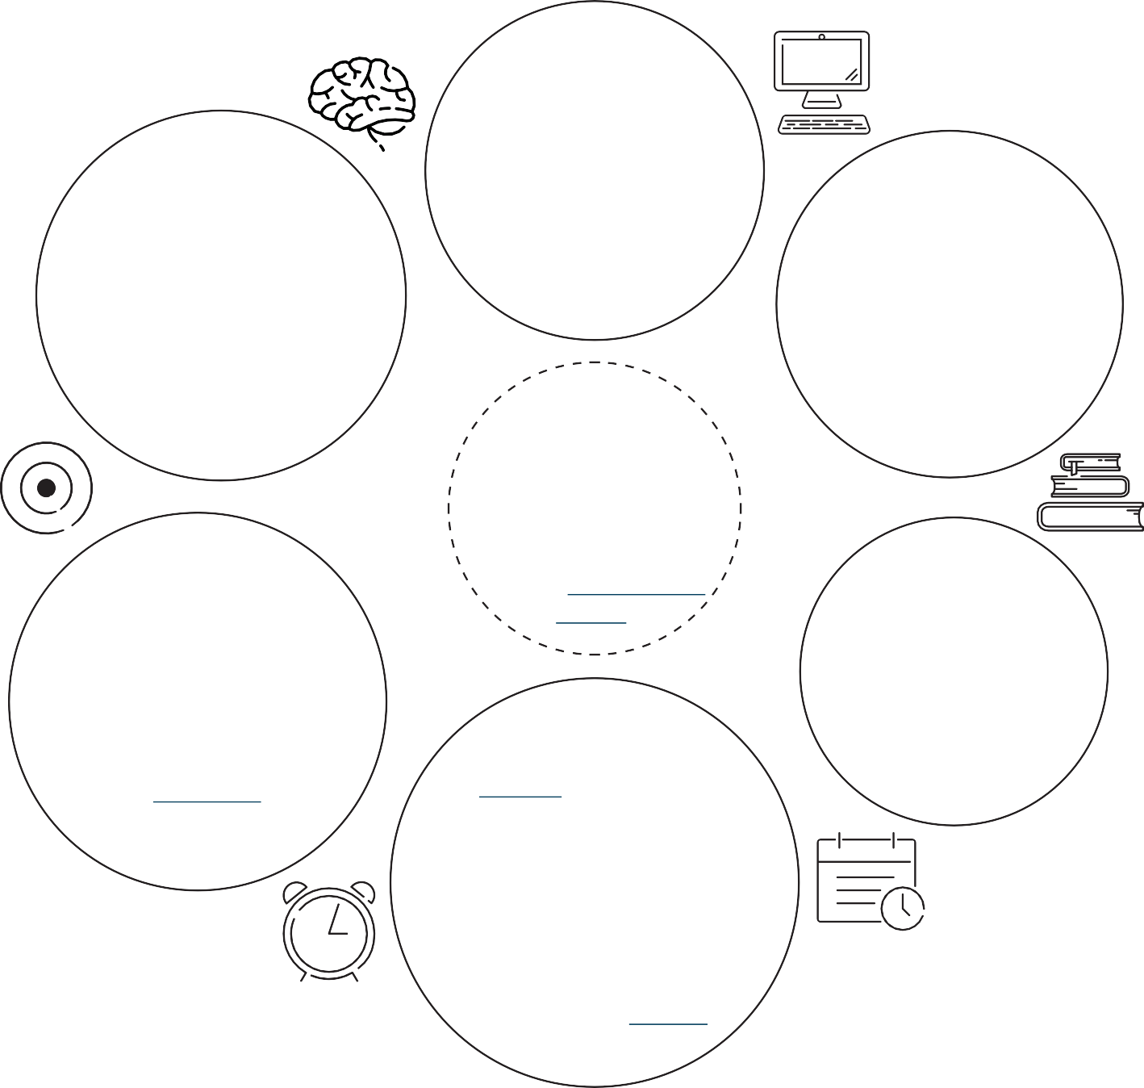
IT CONSISTENT
This will be your learning space rather than a classroom or auditorium. Make it a place you want to be. Think about visuals, seating, table
space, light, plants, air quality, etc.

INTERNET MATTERS
Learning remotely, you’ll want access to a reliable internet connection. Check out this OSU resource page for home internet options.

SET A SCHEDULE
A schedule helps you stay on track and work efficiently. Learning remotely could mean working at your own pace or participating in live class sessions. You can schedule blocks of time throughout your day and week to
stay on track. Remember to include non-academic commitments, stop times, breaks, and self-care in
your schedule.

REMOVE DISTRACTIONS
Close unnecessary browsers and apps. If your phone is not needed, silence notifications and place it out of reach. It may also help to create visual cues for other people like a sign indicating when you’re working.

HAVE ALL THAT YOU NEED
Prepare your space.
Gather everything you’ll need to study: books, technology, chargers, notes, paper, writing utensils, water, snacks, etc.

If you’re learning remotely, your study space may also be where you attend live class sessions or visit office hours. Visual and physical cues may help create routine. Some people find it helpful to create a ritual or sequence of actions to prepare for studying, or to dress as they would if attending an in-person class.
We all work best in different spaces or environments. Some people like organized, meticulous spaces; others appreciate creative chaos. Make your space one that works for you.
If the space doesn’t work, take time to figure out why. Evaluate your study space, make changes, and work to create an environment where you can learn effectively.

